LEADERSHIP AWAKENINGTM: Management & Leadership Concepts using Music as a Metaphor
Tuesday, 10th December, 2019,
Time 4.30 pm – 8.00 pm
IMC Churchgate
Dear Sir/ Madam,

IMC Chamber of Commerce and Industry organizes a workshop on “LEADERSHIP AWAKENINGTM: Management & Leadership Concepts using Music as a Metaphor” designed by Learning Soil Edu on Tuesday, 10th December, 2019.
Learning Soil Edu is a Learning & Development company which does Psychometric Assessments and full-day experiential learning workshops on Leadership Development.
About the Program: A curtain raiser to an innovative experiential learning program on management and leadership concepts using live music, storytelling and case studies by renowned leadership coach Mr Arnab Mallik.
About the Facilitator:
Mr Arnab Mallik, Co-Founder, Learning Soil Edu, is an alumnus of IIM Ahmedabad with 25 years of experience in Fortune 100 companies. A Sangeet Visharad, Mr Arnab brings out various facets of management & leadership through music & corporate storytelling.
Some glimpses of the program: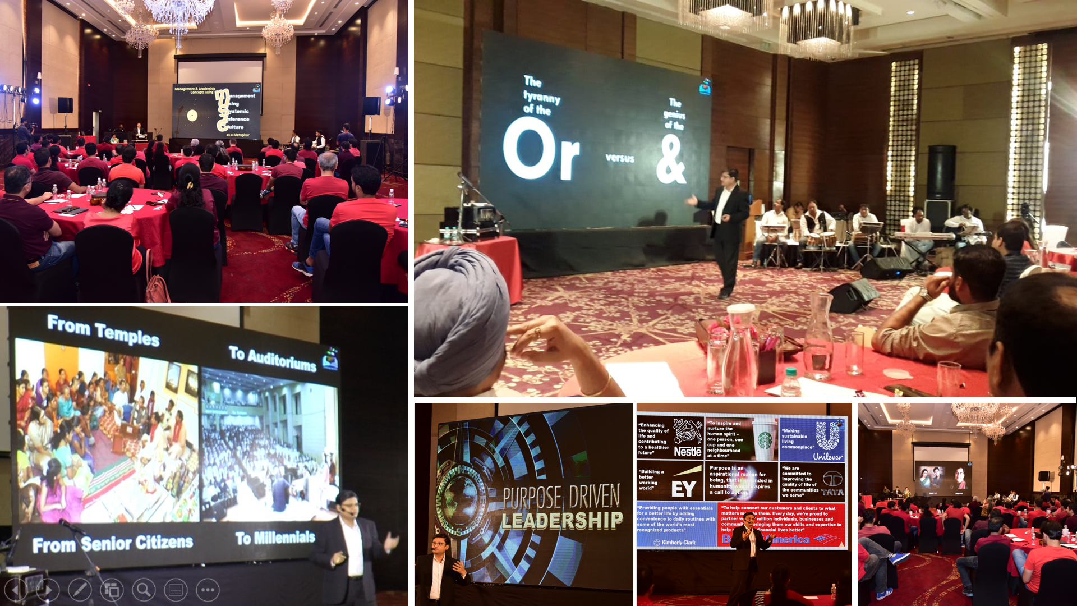
Audience Speak
https://www.youtube.com/watch?v=8qZDmnKxTfM&t=21s
www.learningsoil.com
The details of the program are as follows:

Topic: LEADERSHIP AWAKENINGTM: Management & Leadership Concepts using Music as a Metaphor
Date: Tuesday, 10th December 2019
Time: 4.30 pm to 8 pm (followed by High-Tea)
Venue: IMC, Churchgate

Participant Fees: Rs 2500/- inclusive of GST

Kindly register your participation at the earliest by filling up the enclosed link of Registration Form and forward the same to IMC by email: ila.pathakjha@imcnet.org or by post along with DD/ Cheque for applicable amount in favor of “IMC Chamber of Commerce and Industry”.

For registration and further details, please contact the Education Department of IMC Chamber of Commerce and Industry, on Tel. No. 022-71226666/33 or email on ila.pathakjha@imcnet.org or visit the website www.imcnet.org .

With regards,

Ajit Mangrulkar
Director-General

